INTRODUCTION TO COMPUTER AND DATA PROCESSING-ICS 2240

MWANGI BRENDA WANGUI-HSB214-0463/2022  
GLORIA KADZO-HSB214-0483/2022

ABDI HARO-HSB214-0092/2022

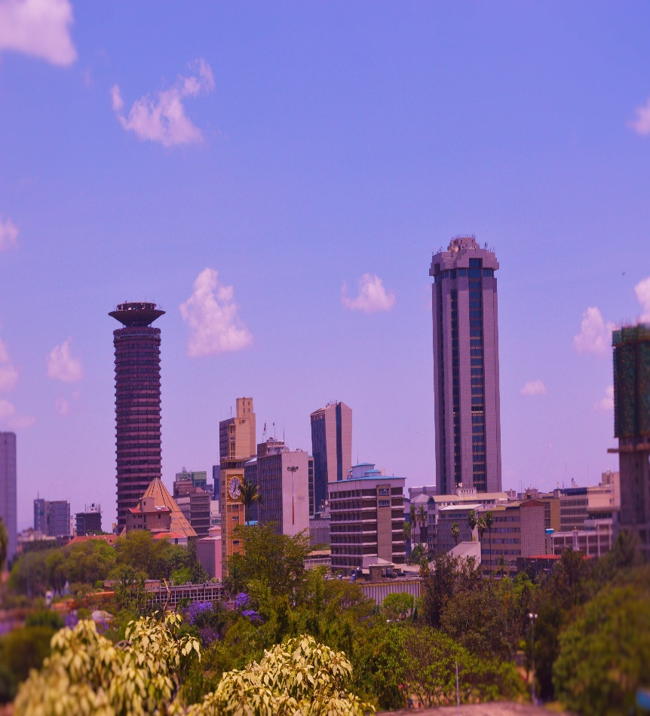

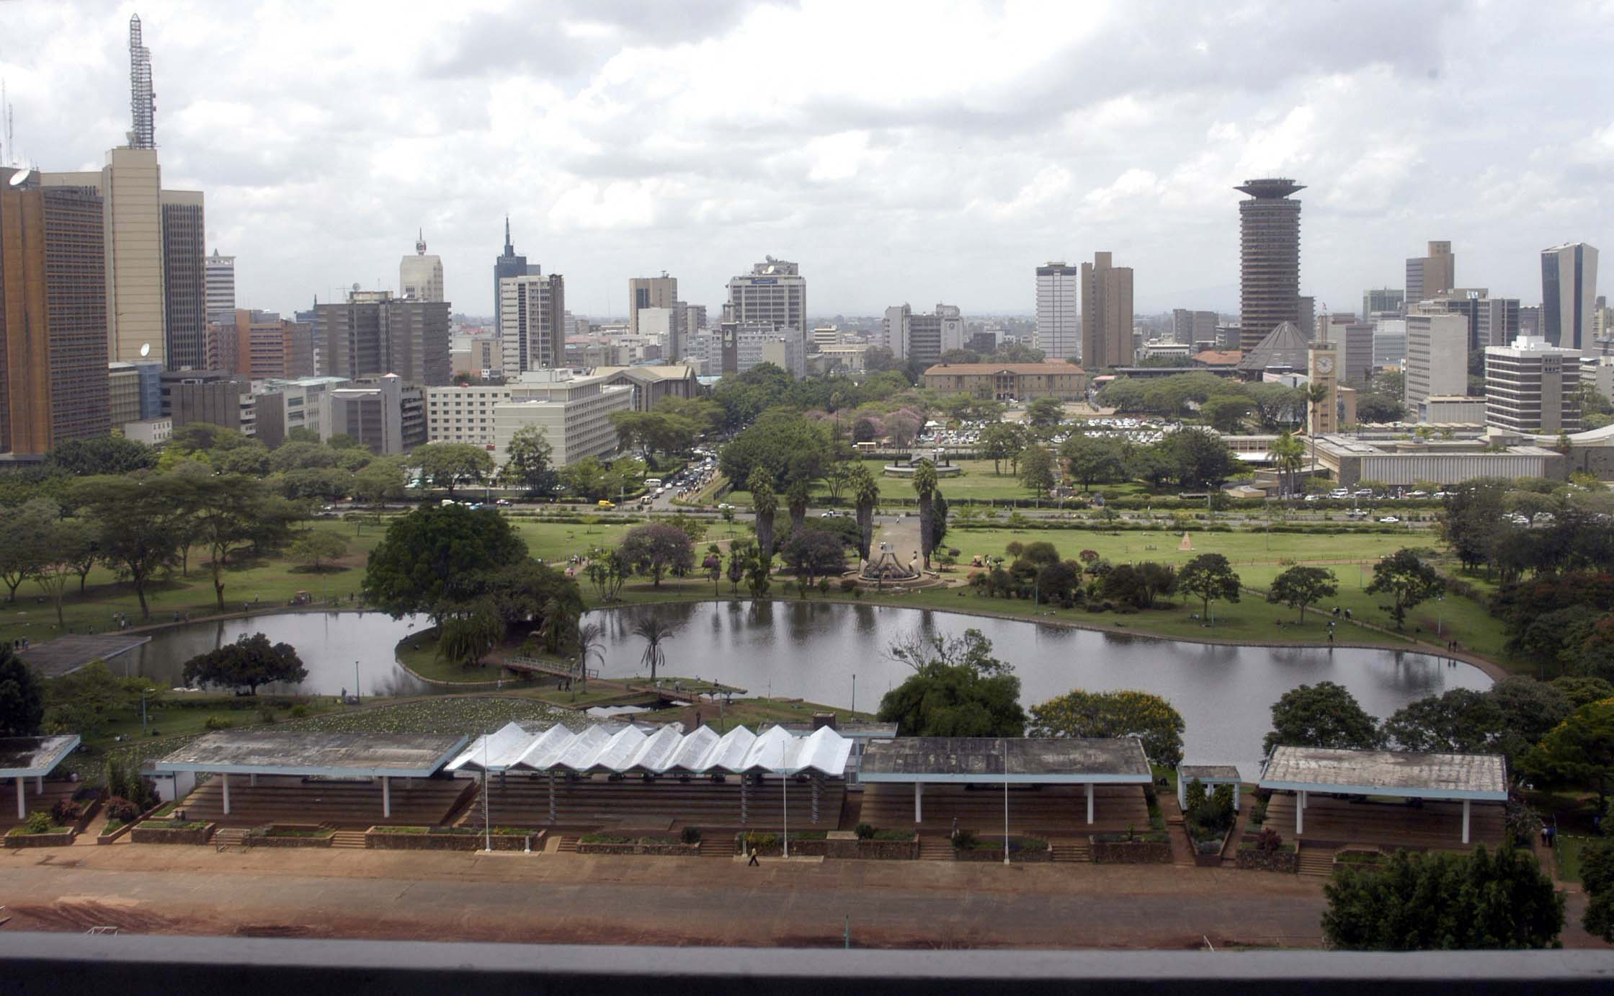Nairobi is the capital city of Kenya. In addition to its urban core the city has Nairobi National park,a large game reserve known for breeding endangered black rhinos and home of giraffes,zebras and lions.next to it is a well-regarded elephant orphanage operated by the david sheldrick wildlife trust.

The city prevalently alluded to as green city in the sun,is without doubt the most beautiful ciy in east Africa.its bustling focal business local,incredible wildlife and friendly people genuinely make it an exceptional spot.

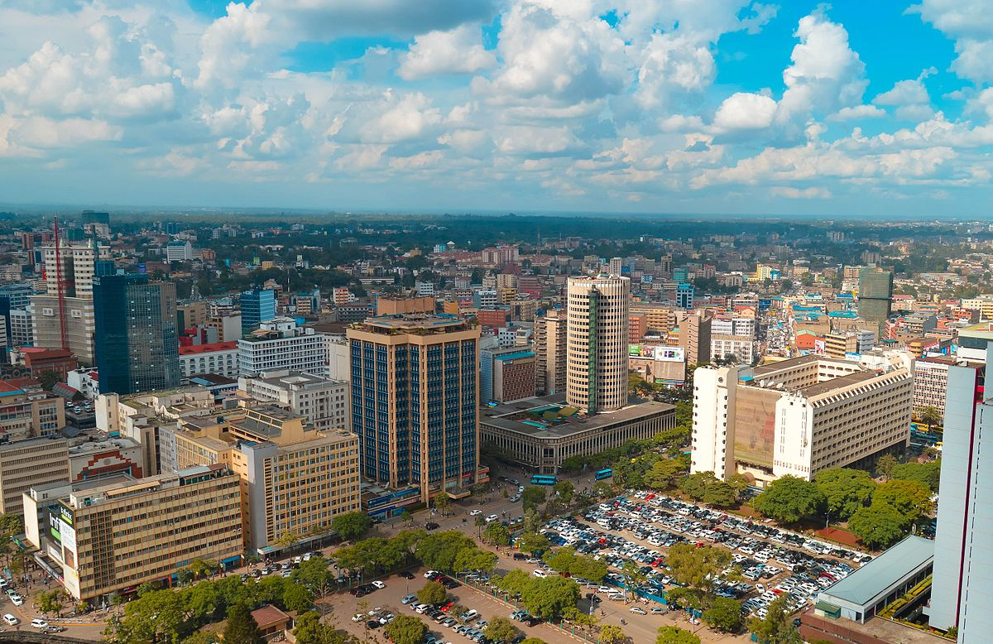Nairobi is the principal industrial centre of the country. The railways are the largest single industrial employer. Light-manufacturing industries produce beverages, cigarettes, and processed food. Tourism is also important. The city is located near [eastern Africa’s](https://www.britannica.com/place/eastern-Africa) agricultural heartland, and a number of primary products are routed through Nairobi before being exported via Mombasa. Nairobi also plays an important role in the [community](https://www.merriam-webster.com/dictionary/community) of eastern African states; it is the headquarters of important regional railways, harbours, and airways corporations.

1. The city is well served by roads and railways. The main routes are southeast and south to Mombasa and [Tanzania](https://www.britannica.com/place/Tanzania) and northwest via the highlands to [Lake Victoria](https://www.britannica.com/place/Lake-Victoria) and [Uganda](https://www.britannica.com/place/Uganda).
2. [Jomo Kenyatta](https://www.britannica.com/biography/Jomo-Kenyatta) International Airport, 9 miles (15 km) to the southwest, is one of the chief international airports in Africa

Nairobi was founded in 1899 by colonial authorities in [British East Africa](https://en.wikipedia.org/wiki/British_East_Africa), as a rail depot on the [Uganda](https://en.wikipedia.org/wiki/Uganda#Railroad) - [Kenya Railway](https://en.wikipedia.org/wiki/Rail_transport_in_Kenya).[[10]](https://en.wikipedia.org/wiki/Nairobi#cite_note-Greenway-11) The town quickly grew to replace [Mombasa](https://en.wikipedia.org/wiki/Mombasa) as the capital of Kenya in 1907.[[11]](https://en.wikipedia.org/wiki/Nairobi#cite_note-12) After independence in 1963, Nairobi became the capital of the [Republic of Kenya](https://en.wikipedia.org/wiki/Republic_of_Kenya).[[12]](https://en.wikipedia.org/wiki/Nairobi#cite_note-13) During Kenya's colonial period, the city became a centre for the colony's [coffee](https://en.wikipedia.org/wiki/Coffee), [tea](https://en.wikipedia.org/wiki/Tea) and [sisal](https://en.wikipedia.org/wiki/Sisal) industry.[[13]](https://en.wikipedia.org/wiki/Nairobi#cite_note-14)[[14]](https://en.wikipedia.org/wiki/Nairobi#cite_note-15) The city lies in the south central part of Kenya, at an elevation of 1,795 metres (5,889 ft).

Nairobi is home of the [Kenyan Parliament Buildings](https://en.wikipedia.org/wiki/Parliament_Buildings_(Kenya)) and hosts thousands of Kenyan businesses and over 1000 major international companies and organizations, including the [United Nations Environment Programme](https://en.wikipedia.org/wiki/United_Nations_Environment_Programme) (UN Environment) and the [United Nations Office at Nairobi](https://en.wikipedia.org/wiki/United_Nations_Office_at_Nairobi) (UNON).

Nairobi population over years

|  |  |  |  |
| --- | --- | --- | --- |
| year | 2021 | 2022 | 2023 |
| population | 4,922,000 | 5,119,000 | 5,325,000 |